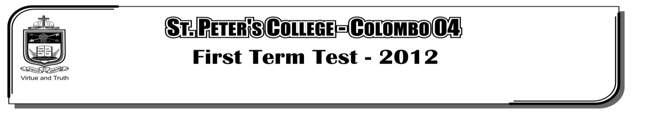

**FIRST TERM TEST - 2019**

**GRADE 11 – Physical Education**

**Part II**

**Answer all question**

01. i. What is meant by “correct posture”?

ii. What are the main types of posture? Provide examples?

iii. Draw a diagram and show the path of the centre of gravity of a long jumper from the time he

takes off until he lands? **(2+4+4=10 Marks)**

02. i. What are the factors affecting the distance or height of the jump of an athlete?

ii. What are the 03 factors that determine the path that a sports equipment takes in a throwing event?

iii. Write six principles of biomechanics? **(2+2+6=10 Marks)**

03. i. How many rounds are there in a volleyball game?

ii. How many marks should be scored to win each round? Write separately.

iii. According to the positions in volleyball? Name 02 places of players.

iv. Write the main methods of blocking? **(1+3+3+3=10 Marks)**